

LOUISVILLE URBAN LEAGUE
YOUTH DEVELOPMENT AND EDUCATION DEPARTMENT
SUMMER REACH PROGRAM WORKSHOP/ACTIVITY EVALUATION

Please let us know how we are doing by taking a few minutes to complete this evaluation. We appreciate your honest opinion. The information from evaluations is helpful with program planning. Thank you for sharing your opinion with us.

Activity: _________________________________________________________ Date: ____________________________, 2009

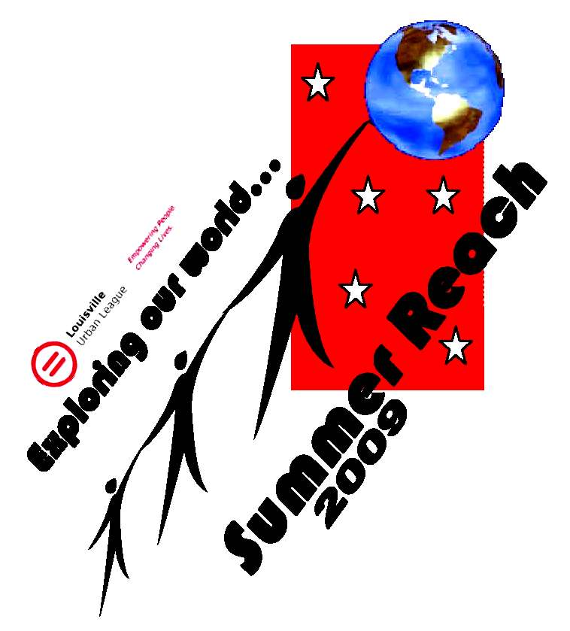
Instructions: Please circle one for each question.

Highest Rating……………….…..........….Lowest Rating
5 4 3 2 1

Would you recommend this activity to your friends? 5 4 3 2 1

Do you feel the information was useful? 5 4 3 2 1

Do you feel the presenter was encouraging? 5 4 3 2 1

Do you feel the presenter was happy to share the information? 5 4 3 2 1

How could this activity be improved?______________________________________________________________________________

Out of the information presented in the activity, what information do you think was most useful? Please list three things you learned during this activity.
___________________________________________________________________________________________________________

___________________________________________________________________________________________________________

___________________________________________________________________________________________________________

___________________________________________________________________________________________________________

Please express additional comments about activities and/or presenters___________________________________________________

Name _____________________________________________ Grade___________________________________________


Please return to Imani A. Muhammad, Program Assistant
Youth Development and Education Department Louisville Urban League

